Abstract template for the LASI 6 Conference
(Malargüe, Argentina)

First_Author N.¹, Second_Author N.² and Third_Author N.³

¹ Department, University, City, Country – email address
² Institute, Street, City, Country
³ Company, Street, City, Country

Keywords: insert, three, keywords.

This template is an example of how to prepare an abstract for the LASI 6 Conference to be held on 25-26 November 2019 (Malargüe, Argentina). The simplest way to comply with the requested abstract format is to replace the text in this template with your text.
The title has to be typed in font Arial 14 pt bold.
The Authors’ names have to be typed in Arial 9 pt, with the presenting Author (either for oral or poster presentation) in boldface.
The Authors’ affiliations have to be typed in Arial 8 pt italics. The email address of the presenting Author is requested, and he/she will be referred to also as the Corresponding Author.
Three Keywords have to be supplied and typed in Arial 8 pt.
The main text has to be typed in Times New Roman 10 pt.
Black/white and greyscale graphics/figures are allowed and welcome. Colour figures are allowed if concentrated in a single page of the abstract (either the first or the second), i.e. no more than one colour page per abstract is accepted. Figures can be either one column-wide (7.5 cm) or two column-wide (between 7.5 and 16 cm). Any figure should be inserted in the text as a JPG file with 300 dpi resolution.
A brief paragraph with Acknowledgements may be added at the end of the main text.
A limited number of citations in the text are welcome, and the relevant list of references has to be added at the end of the abstract. The ways to cite in the text are: Alighieri (1321), for single-author papers; Lyell and Smith (1830), for two-authors papers; Buonarroti et al. (1505), if the authors are more than two. The reference format is shown in the Reference paragraph at the end of this template.
The length of the abstract cannot exceed two pages in this format. On the other hand, the Authors are strongly encouraged to submit informative abstracts longer than a single page.
The abstract can be submitted either as a .DOC or .RTF file. The .DOC format is preferred for abstracts including figures to keep the file size as low as possible.
The abstract has to be submitted by email to the address Olivier.galland@geo.uio.no not later than 1st July 2019. Together with the abstract, the Authors have to indicate in the Registration Form their preferred mode of presentation, either oral or poster. The Organizing Committee will allocate a maximum number of oral presentations, with the remainder as posters. Thus some presentations proposed as oral by the Authors could turn to posters, while no presentations proposed as posters by the Authors will become oral presentations without permission from the Corresponding Author.

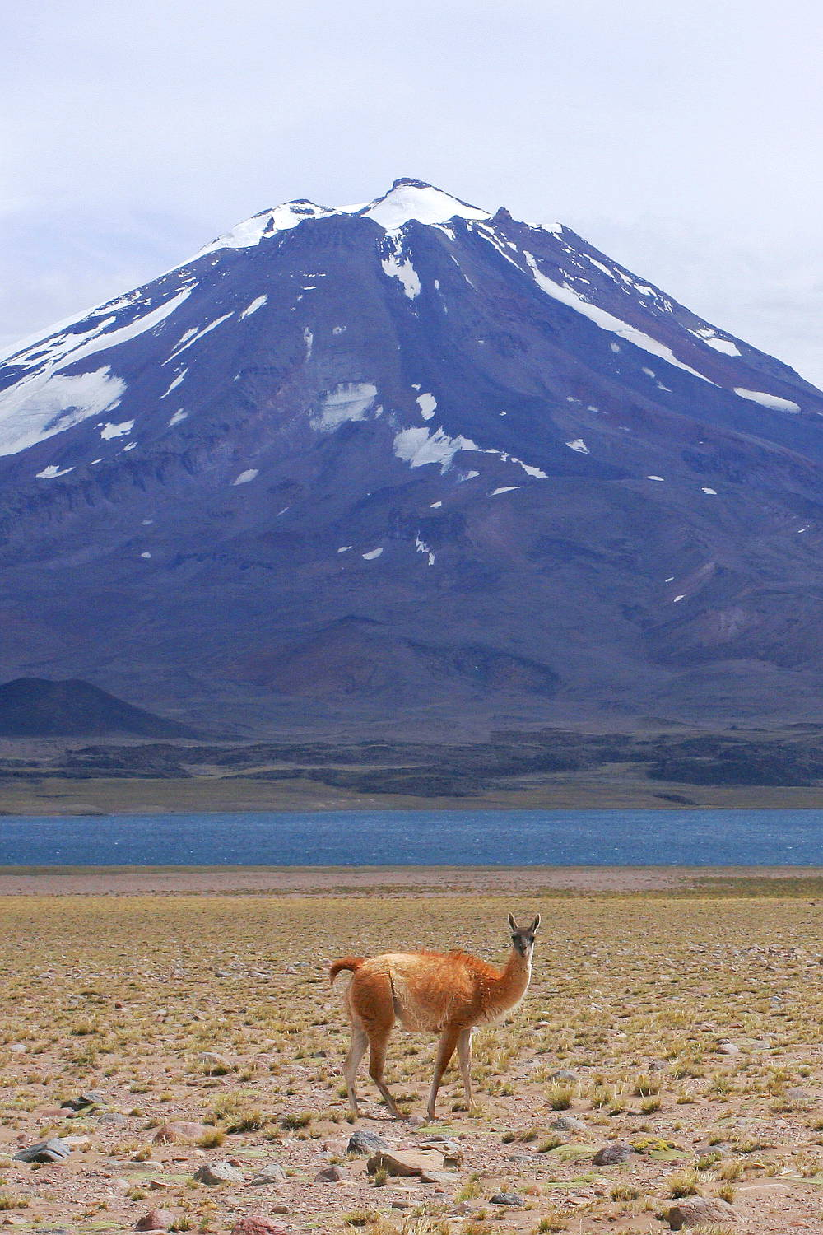
Fig. 1 – The caption(s) of the figure(s) should be typed in this format. The font to be used is Arial 8 pt.

This sentence is written just to fill the available space and contains no useful information for the abstract submission. This sentence is written just to fill the available space and contains no useful information for the abstract submission. This sentence is written just to fill the available space and contains no useful information for the abstract submission.
This sentence is written just to fill the available space and contains no useful information for the abstract submission. This sentence is written just to fill the available space and contains no useful information for the abstract submission. This sentence is written just to fill the available space and contains no useful information for the abstract submission.

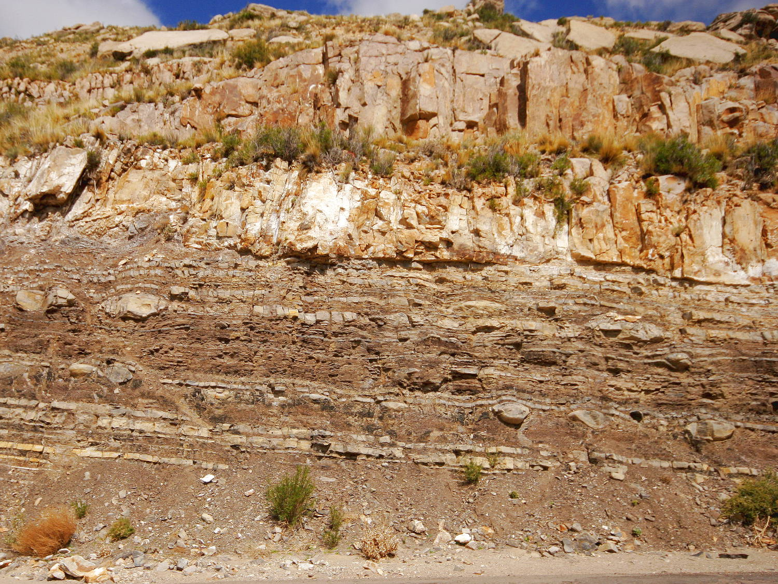
Fig. 2 – The caption(s) of the figure(s) should be typed in this format. The font to be used is Arial 8 pt.

This sentence is written just to fill the available space and contains no useful information for the abstract submission. This sentence is written just to fill the available space and contains no useful information.

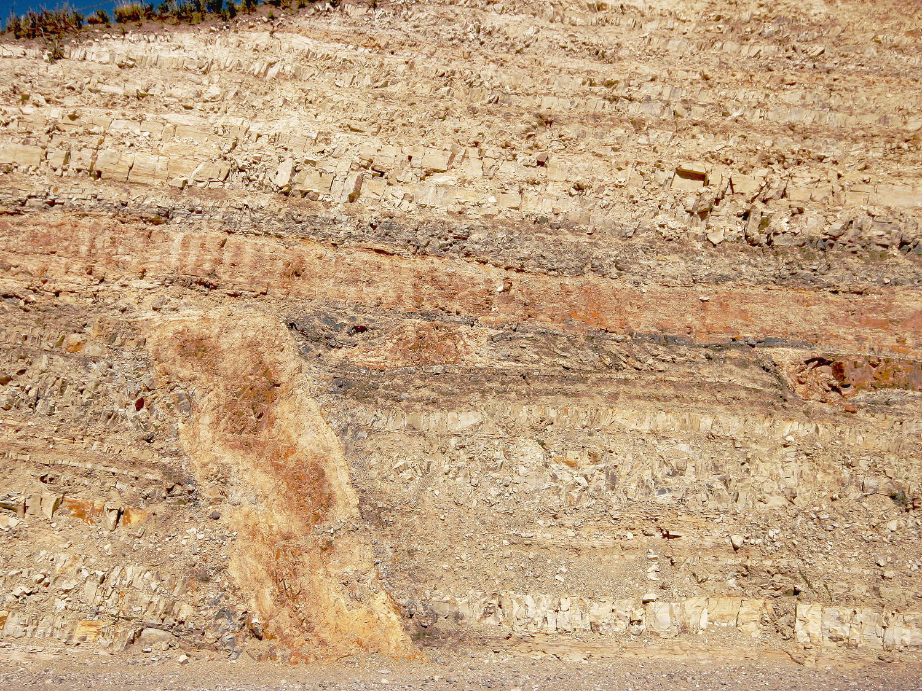
Fig. 3 – The caption(s) of the figure(s) should be typed in this format. The font to be used is Arial 8 pt.

This sentence is written just to fill the available space and contains no useful information for the abstract submission. This sentence is written just to fill the available space and contains no useful information for the abstract submission. This sentence is written just to fill the available space and contains no useful information for the abstract submission. This sentence is written just to fill the available space and contains no useful information for the abstract submission. This sentence is written just to fill the available space and contains no useful information for the abstract submission. This sentence is written just to fill the available space and contains no useful information for the abstract submission. This sentence is written just to fill the available space and contains no useful information for the abstract submission. This sentence is written just to fill the available space and contains no useful information for the abstract submission.

Acknowledgements

All the Authors are kindly thanked for having submitted an abstract formatted according to this template.

References

Bertelsen, H. S., B. D. Rogers, O. Galland, G. Dumazer, and A. Abbana Bennani (2018), Laboratory modelling of coeval brittle and ductile deformation during magma emplacement into viscoelastic rocks, Frontiers in Earth Science, 6.
Galland, O., et al. (2018), Storage and transport of magma in the layered crust-Formation of sills and related float-lying intrusions, in Volcanic and Igneous Plumbing Systems, edited by S. Burchardt, pp. 111-136, Elsevier.
Guldstrand, F., S. Burchardt, E. Hallot, and O. Galland (2017), Dynamics of Surface Deformation Induced by Dikes and Cone Sheets in a Cohesive Coulomb Brittle Crust, Journal of Geophysical Research: Solid Earth, 122(10), 8511-8524.
Haug, Ø. T., O. Galland, P. Souloumiac, A. Souche, F. Guldstrand, T. Schmiedel, and B. Maillot (2018), Shear versus tensile failure mechanisms induced by sill intrusions -- Implications for emplacement of conical and saucer-shaped intrusions, Journal of Geophysical Research: Solid Earth, 123, 3430-3449.
Schmiedel, T., O. Galland, Ø. T. Haug, G. Dumazer, and C. Breitkreuz (2019), Coulomb failure of Earth's brittle crust controls growth, emplacement and shapes of igneous sills, saucer-shaped sills and laccoliths, Earth Planet. Sci. Lett., 510, 161-172.
Spacapan, J. B., O. Galland, H. A. Leanza, and S. Planke (2017), Igneous sill and finger emplacement mechanism in shale-dominated formations: a field study at Cuesta del Chihuido, Neuquén Basin, Argentina, J. Geol. Soc. London, 174(3), 422-433.

